3- As an admin, I want to remove the item from the list of products of the Campus Café so that they will no longer be available for customers when they order.

4- As a customer, I want to see every item available in the Campus Café so that I know what I may order.

6- As a barista, I want to see all the pending orders so that I can start one at a time.

7- As a barista, I want to mark an order as complete so that a customer can collect it.

11- As a customer, I want to be able to remove an item from my order during the ordering process in case I change my mind.

LIST OF NEW VIEWS:

* CUSTOMER VIEW: REWORKED
* ORDER VIEW
* BARISTA VIEW

SPRINT GOAL:

Three new views. They work. Able to remove items from the list of products. Able to see every item from the list, add them to an order and remove them. BARISTA: see all orders. Mark an order as complete.

| PB-ID | ID | Task Title | Responsible | Estimate (hours) | Status |
| --- | --- | --- | --- | --- | --- |
| 3 | 1 | Implement Remove Item from Product List button functionality | Robert | 3 | Completed |
| 3 | 2 | Little documentation ^^^^ | Robert | 3 | Completed |
| 4 | 3 | Design & create Customer view (FXML) | Kamil | 2 | Completed |
| 4 | 4 | Implement viewmodel & view controller ^^^^ | Kamil + Robert | 16 (8*2) | Completed |
| 4 | 5 | Document Customer view ^^^^ | Kamil + Robert + Daniel | 8 (2,6*3) | Completed |
| 4 | 6 | Design & Create Order view (FXML) | Kamil | 2 | Completed |
| 4 | 7 | Implement viewmodel & view controller ^^^^ | Kamil + Robert | 8 (4*2) | Completed |
| 4 | 8 | Document Order view ^^^^ | Kamil + Robert | 8 (4*2) | Completed |
| 6 | 9 | Design & create Barista view (FXML) | Laura | 6 | Completed |
| 6 | 10 | Implement viewmodel & view controller ^^^^ | Laura | 6 | Completed |
| 7 | 11 | Implement Complete Order button functionality | Laura | 4 | Completed |
| 7 | 12 | Document Barista view ^^^^ | Laura | 4 | Completed |
| 11 | 13 | Implement Remove Item from Order button functionality | Kamil | 2 | Completed |

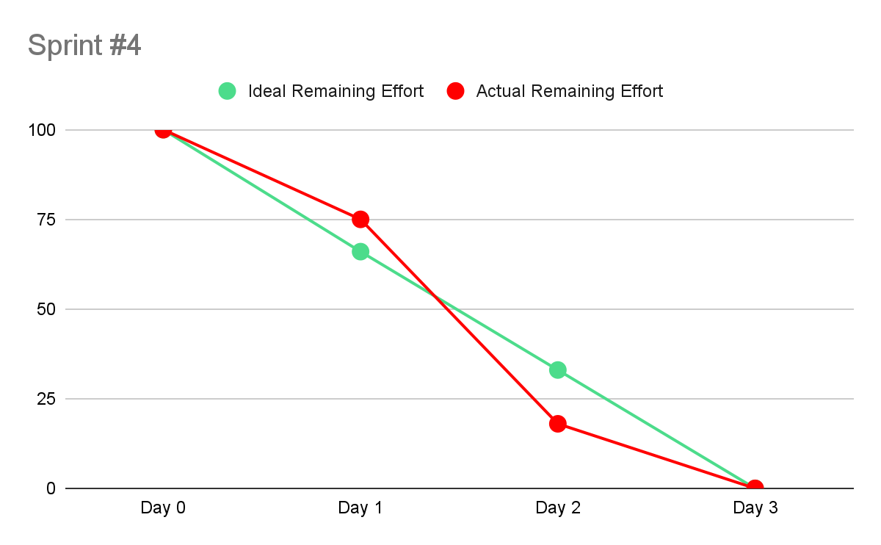

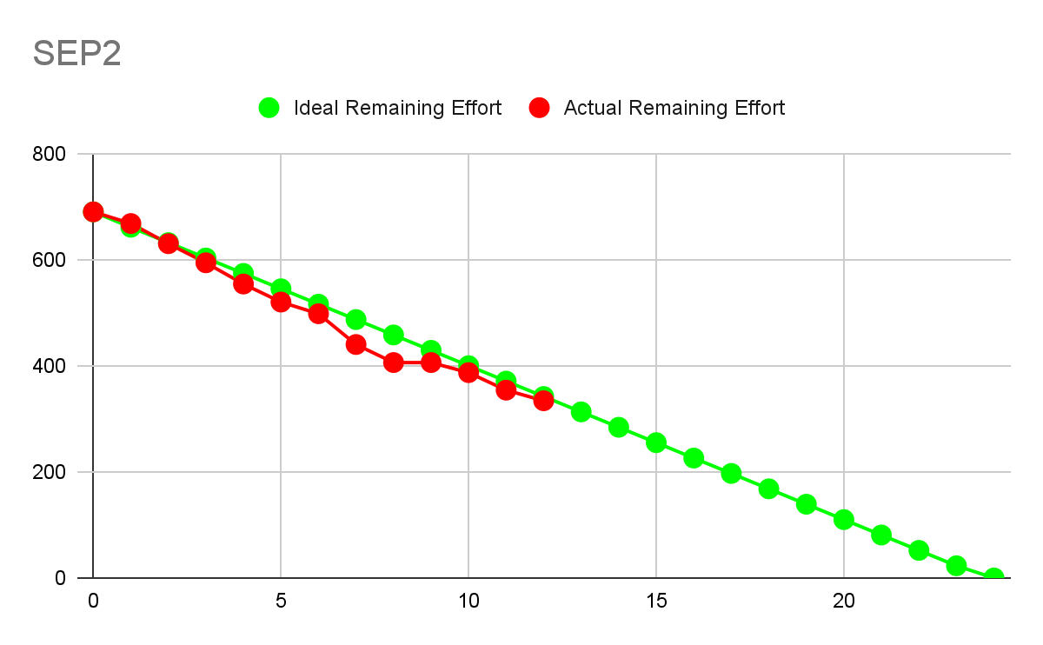

**WHAT WAS ACHIEVED:**

* The product backlog items set for this sprint were achieved, documentation and testing too
* Implementation of property package to respect the MVVM structure

**WHAT WENT WELL:**

* The implementation of Views and usage of Observable List of type Property was used,
* Documentation is solid.

**WHAT TO DO NEXT:**

* Focus on the PB and implement new views,
* Further build on the system by adding display, payment methods, etc.